UK Safety Alert

SAFE AND SECURE TOOLS AND EQUIPMENT

Details of the Incident
Recent site visits have highlighted that unsecured tools and equipment are being stored inside and on the outside of vehicles. This includes brushes, scrapers, buckets and shovels on the outside of vehicles and shovels, TVs, fridges, tool boxes in vehicle cabs and also laptops inside cars.
Unsecured tools and equipment carried in vehicles, whether a car or LGV cab, are very dangerous and will act as a missile during a harsh braking situation.

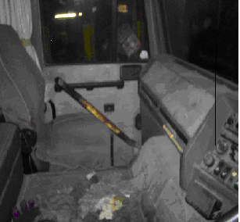 | 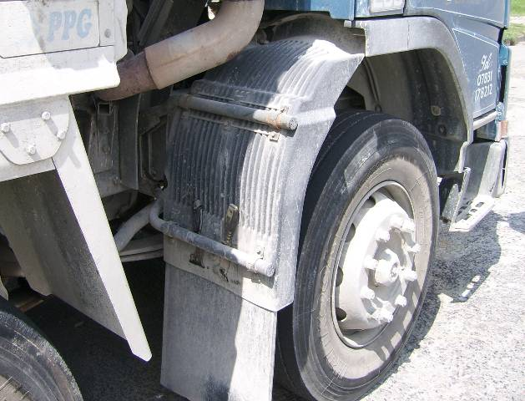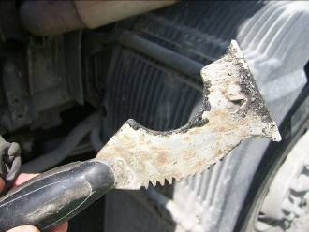

Learning Points

- Scrapers, brushes, buckets and other objects to clean tailgates and other loose material from vehicles have been found wedged in vehicle mudguards, vehicle steps and other locations on the outside of vehicles.
When carrying tools and equipment for cleaning vehicles, do you ensure that they are safely secured so they cannot fly off the vehicle and cause injury / damage?
- It is not uncommon to find items such as shovels and sweeping brushes in the passenger foot well Also fridges/coolboxes, portable stoves, televisions and laptops are all items that have been found stored insecurely in vehicles that could cause serious injury in an incident if they hit someone.
How do you store such items? Are all loose items secured so they cannot move? Do they need to be inside the vehicle? Can shovels be safely secured to the vehicle body? Do car drivers put laptops, etc. in the boot?

